Redis Cache Demo:

Add the below dependency to POM.xml file
----------------------------------------------
<!-- Step 1 Redis -->
<dependency> <groupId>org.springframework.boot</groupId>
<artifactId>spring-boot-starter-data-redis</artifactId>
</dependency>
Add the below properties in properties file
----------------------------------------------
# Redis Config
spring.cache.type=redis
spring.redis.host=localhost
spring.redis.port=6379
Note : it uses Jedis Connection to connect to localhost redis server and give it to RedisTemplate so that AutoConfig of RedisConfiguration will succeed

OR Write the below configuration code in primary configuration

@Bean
JedisConnectionFactory jedisConnectionFactory() {
JedisConnectionFactory jedisConFactory= new JedisConnectionFactory();
jedisConFactory.setHostName("localhost");
jedisConFactory.setPort(6379);
return jedisConFactory;
}

@Bean
public RedisTemplate redisTemplate() {
RedisTemplate template = new RedisTemplate();
template.setConnectionFactory(jedisConnectionFactory());
return template;
}

Installing Redis Server
----------------------------------------------
Download Redis 3.0 Server for Windows as a Zip file from below link
https://github.com/ServiceStack/redis-windows/blob/master/downloads/redis-64.3.0.503.zip
Extract it and double click “redis-server.exe” to start redis server
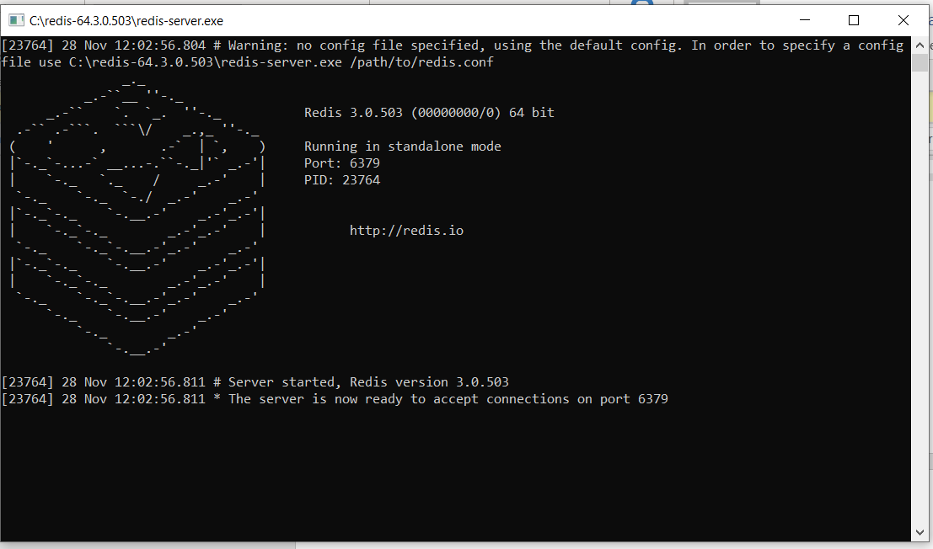

Installing Redis Desktop manager
----------------------------------------------
A 14 days of trail u can use at the below link https://redisdesktop.com/pricing
Give you email id check your email and go with verification.
Download the exe file install and start with UserName and Password.
Then connect to redis server my giving some connection name “myRedis” ip as 127.0.0.1 and port as 6379
Now on your connection db0
Click on load keys
You can see cache data stored in redis server from desktop manager
From here you can manage like delete etc

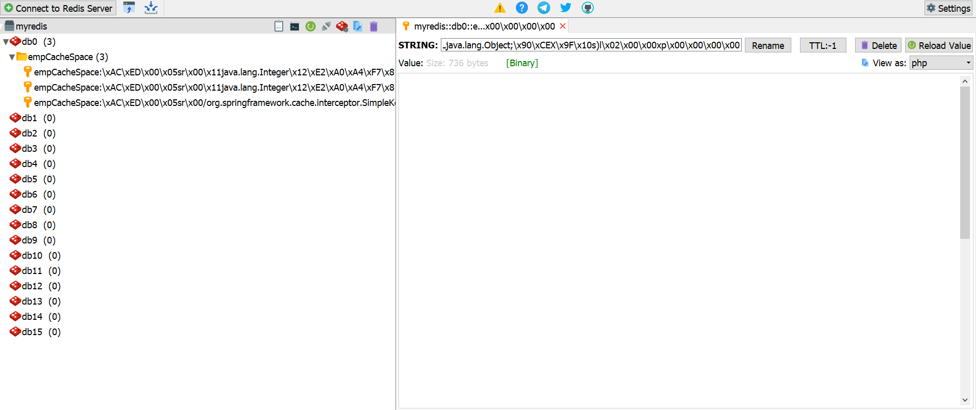

EhCache VS Redis Cache:
You can think Redis as a shared data structure, while Ehcache is a memory block storing serialized data objects. This is the main difference.
Redis as a shared data structure means you can put some predefined data structure (such as String, List, Set etc) in one language and retrieve it in another language. This is useful if your project is multilingual, for example: Java the backend side , and PHP the front side. You can use Redis for a shared cache.
If your project is only Java, i.e. not multilingual, Ehcache is a convenient solution

